**Monitor windows by using Zabbix**

* Download Zabbix agent for windows

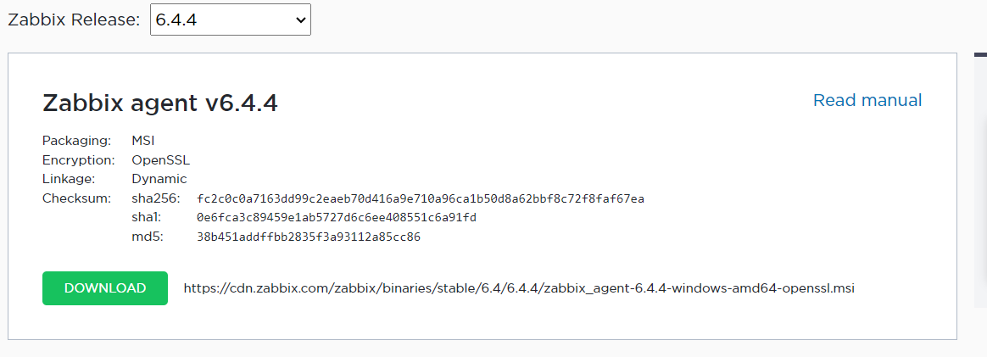

* Complete the installation

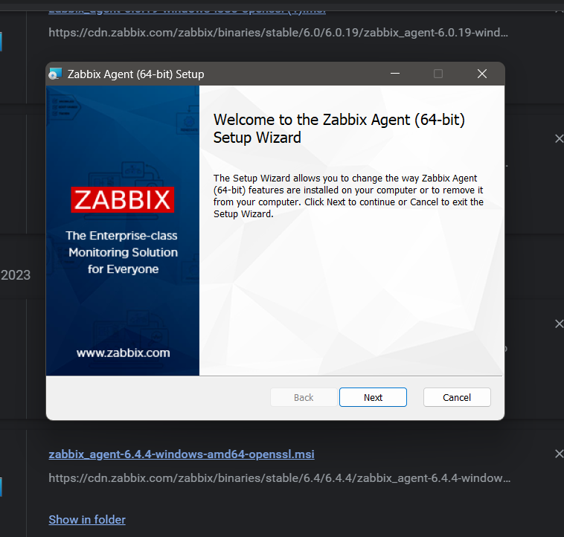

* Edit the Zabbix configuration file
* Locate Zabbix.gentd.conf file in your local disk c and modify the parameters as shown below :

Server=<IP address of the Zabbix server>

ServerActive=<IP address of the Zabbix server>

Hostname=<The FQDN of the Windows server>

* Save the changes and exit the file
* With all the configurations in order, run command prompt as administrator and install Zabbix using the syntax as shown:

C:\> {full system path to zabbix_agentd.exe) –config  {full system path to zabbix_agentd.win.conf} –install

* After the installation start the Zabbix using this syntax:

C:\> {full system path to zabbix_agentd.exe) –start

* To confirm that the Zabbix agent is running, head out to the ‘Windows Services’ application and confirm that the Zabbix agent is up and running.

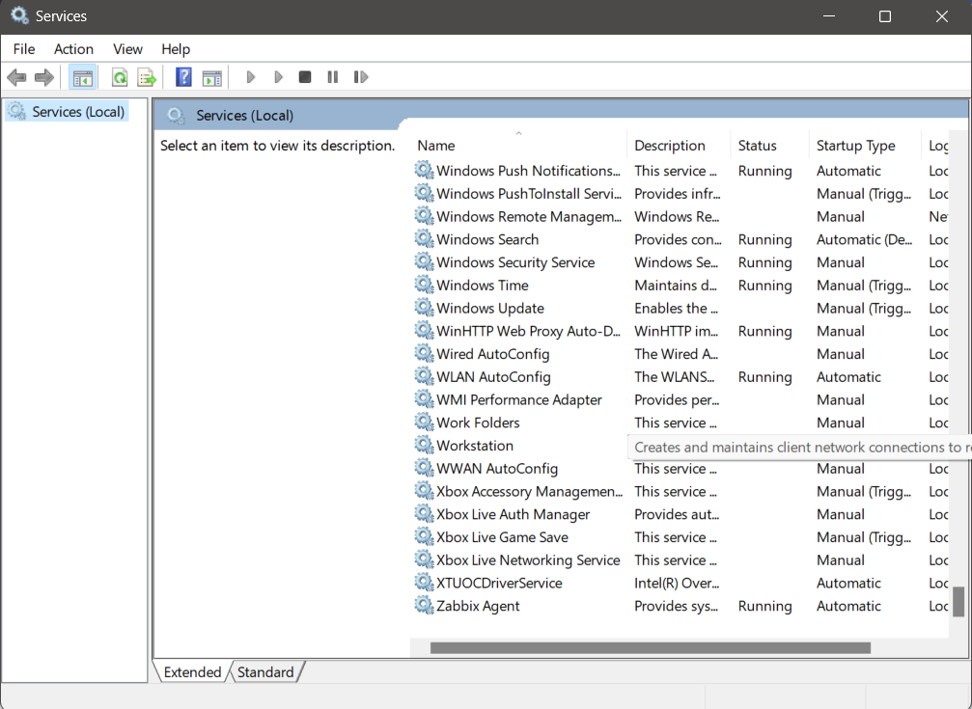

* Configure Windows firewall for Zabbix Agent
* Run the following command in windows powershell

netsh advfirewall firewall add rule name="ICMP Allow incoming V4 echo request" protocol="icmpv4:8,any" dir=in action=allow

* By default, the Windows firewall is enabled and blocks incoming and going connections. We are therefore going to make a few changes to allow traffic from the Windows Server host to the Zabbix server.
* First, we are going to allow ICMP protocol for the Zabbix server to establish network communication with the Windows host and report any errors when they occur. Therefore, run Windows Powershell with Administrative privileges and execute the command as shown
* Next, allows port 10050 – which is the default port that Zabbix listens to – on the firewall.

netsh advfirewall firewall add rule name="Open Port 10050" dir=in action=allow protocol=TCP localport=10050

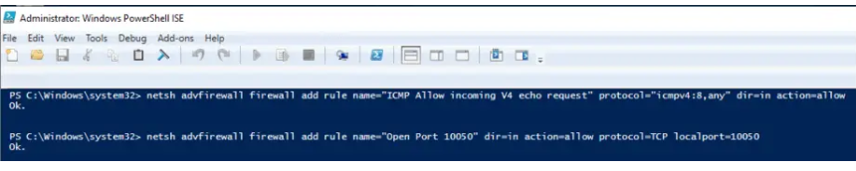

* Add a Windows host on Zabbix Server

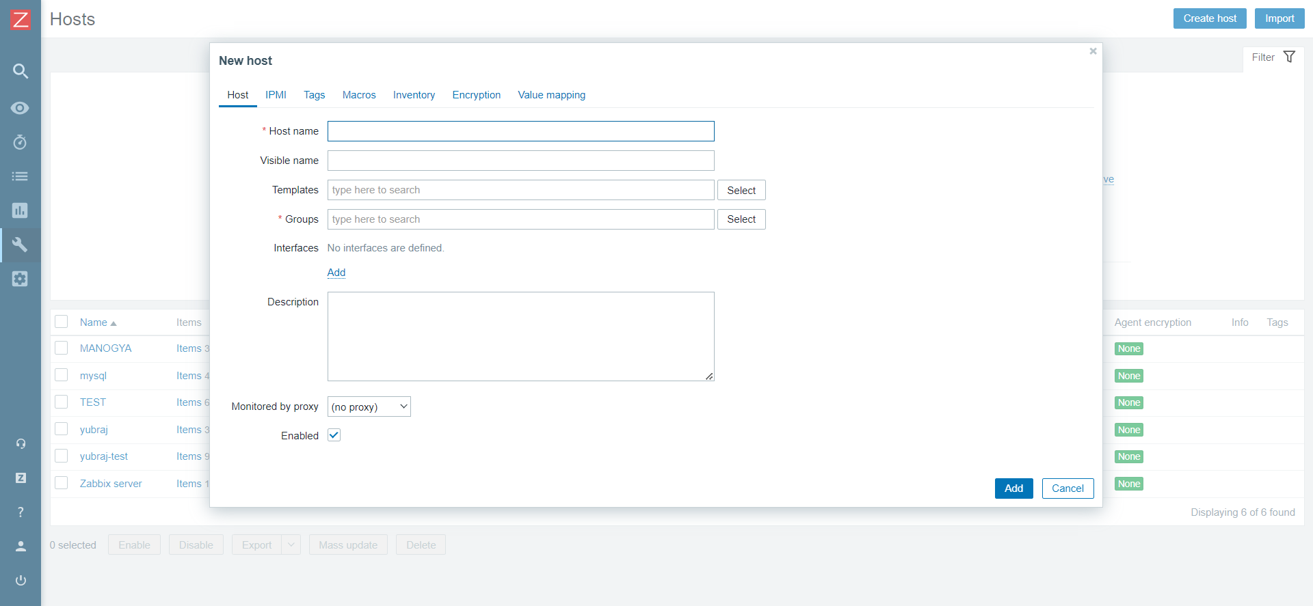

* fill out the Windows host details such as hostname, visible name and IP address

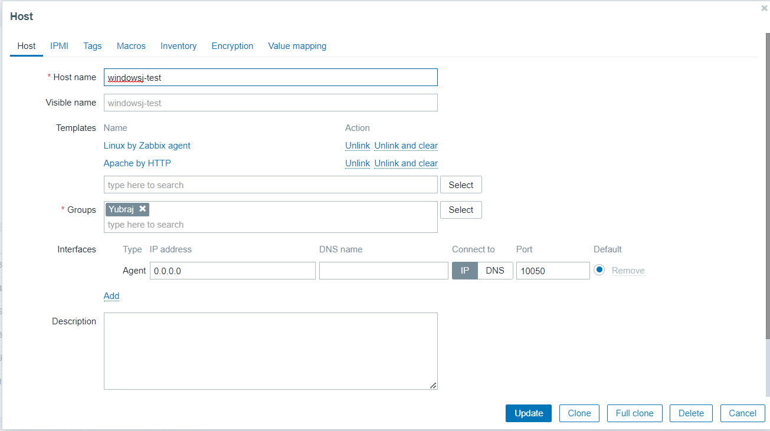

* For the ‘Groups’ section, click on the ‘Select’ button and click on the ‘Templates/Operating system’ option or you can create your own group

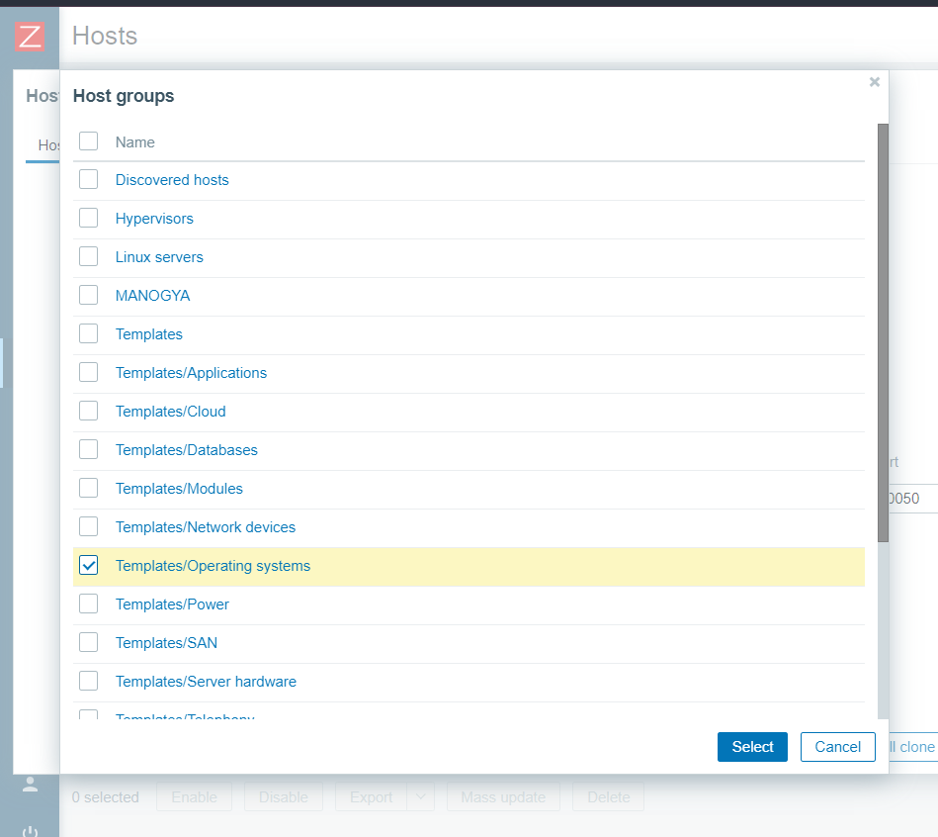

* After selecting host create a host click on the select button
* On the dashboard, check the Windows host listed as shown below. Note that the state is indicated ‘Enabled’ with the Zabbix icon ‘ZBX’ in green color.

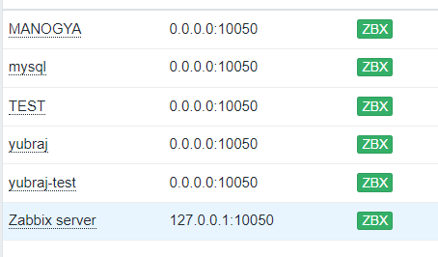

* To graph the metrics associated with the Windows host system, click on ‘Monitoring’ –> ‘Hosts’. Click on the Windows host and select ‘Graphs’.

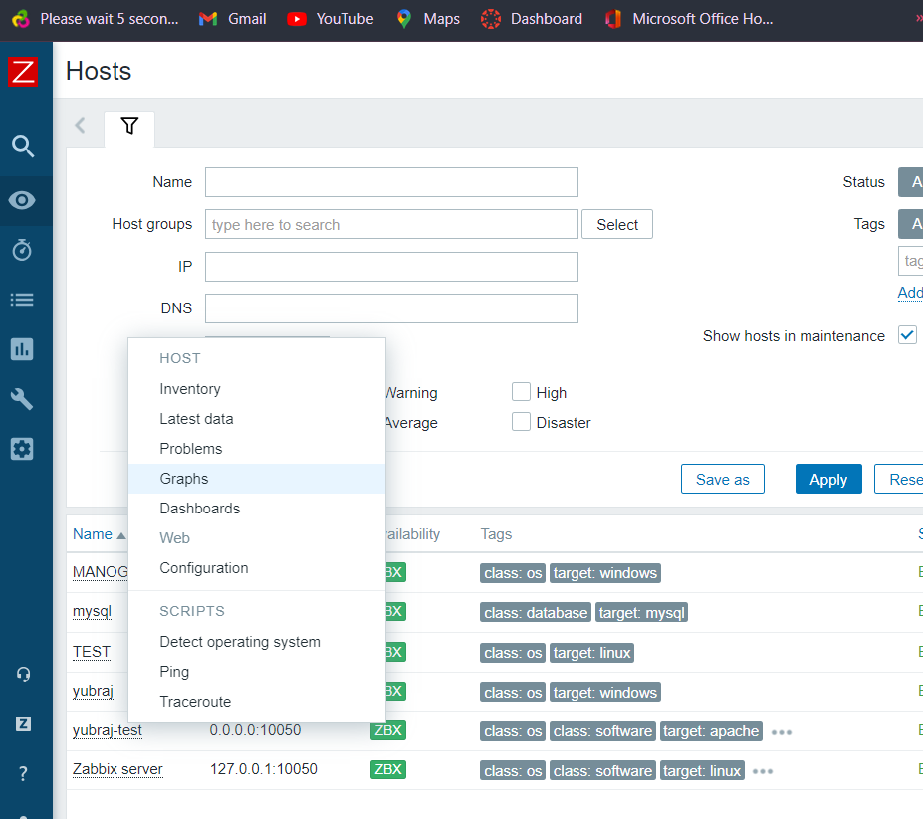

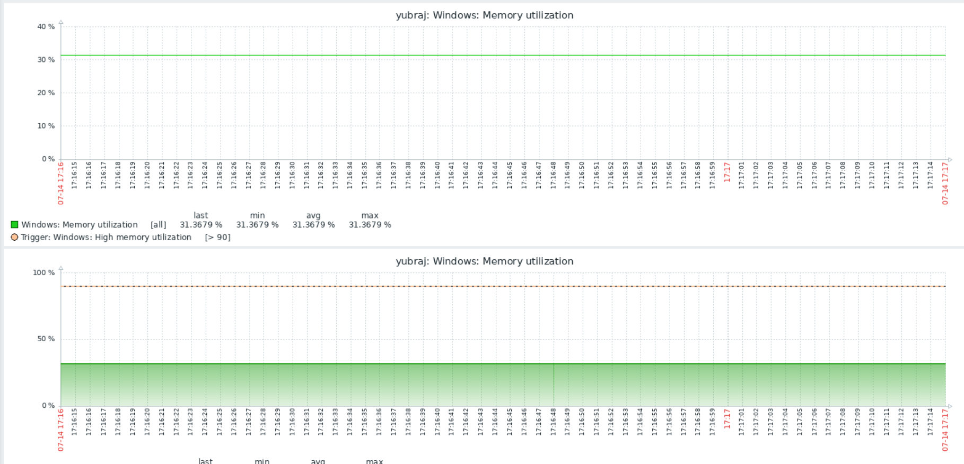

* Finally, the Zabbix server will start graphing the system metrics shipped by the Zabbix agent which is residing on the Windows server host system. There are various metrics that you can monitor including network Interface statistics, CPU usage and utilization, Disk space usage and Memory utilization to mention a few.